Calculus 1 Name
Worksheet – Area Under a Curve Block Date

1) Approximate the area under the curve from to using:
6 Rectangles: Left-hand endpoints
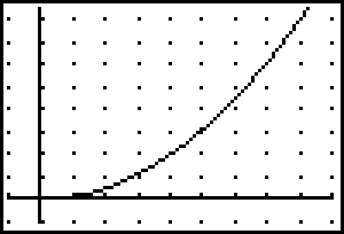

6 Rectangles: Right-hand endpoints

2) Approximate the area under the curve from to using:
12 Rectangles: Left-hand endpoints

12 Rectangles: Right-hand endpoints

3) Approximate the area under the curve from to using:
12 Rectangles: Left-hand endpoints
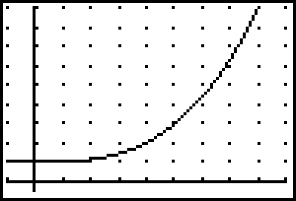

12 Rectangles: Right-hand endpoints

4) Approximate the area under the curve from to using:
24 Rectangles: Left-hand endpoints

24 Rectangles: Right-hand endpoints

